Station5One
2022-2023 Basketball Tournament Series
Station5ONE is offering Competitive Basketball Tournaments for Boys and Girls 3rd Gr through High School. Station5one is centrally located from all major cities.

Event Date
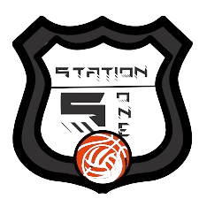
Oct 22 and 23 Feb 18 and 19
Nov 26 and 27 Mar 11 and 12
Dec 17 and 18 April 15 and 16
May 6 and 7

Deadline: 2 weeks before tournament
Format: Guarantee 3 games

Fee: $125 per Team
There will be a spectator fee charged at the door.

Register: Go to our website, www.station5one.com and download the tournament
Registration form. Mail Forms To:
Station5One – 404 Olympia Dr. – Bloomington, Il. 61704

Make Checks Payable to: Midwest Hoopstars

Contact Info: 309-662-9520 – info@station5one.com

