2022 Corporate Fall Basketball League

Station5One is excited to offer a Corporate Adult Fall Basketball League. Sign up your small business to large corporation teams to improve company exposure and teamwork while being part of a great community activity. We offer both a competitive and recreational division, but will combine divisions if needed.

Deadline: Sept 19, 2022
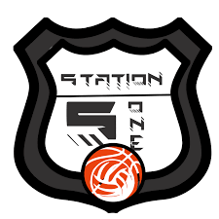
Start Date: Oct 10, 2022

End Date: Dec 12, 2022

Cost: $600/Team

Jerseys: All team members must
have the same basketball jersey.
Station5One jerseys are available to order for $25

Games: 8 League Games
Plus Post Season
For Qualifying Teams

Mail registrations to 404 Olympia Dr. Bloomington, Il. 61704
Please Make Checks Out to - Midwest Hoopstars

Questions: Call Station5One at 309.662.9520 or email us at info@station5one.com

