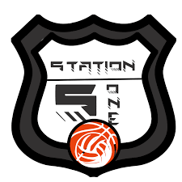
Hustle Hit Never Quit

Open Pickleball Play Dates

Winter 2022 and 2023 Season

Station5One of Bloomington, IL is pleased to host daily open play dates for 2022-2023 season. We are excited to announce we are adding one additional portable court giving

us 6 total courts.

New this year are Court Reservation memberships. Reserve a court up to twice a week. You can play in a reserved group twice a week. Monthly unlimited fee is $40 per person and you can still play during open play.

Event Details: Station5One will have open pickleball play -
Monday through Friday
800am to 200pm all hours every day.
Court reservation available between 10:00-2:00pm each day
*Can Reserve Court for 2 Hours/Day*
6 courts on Hardwood Surfaces

Registration Fee: Membership - $30 per month unlimited play per person.
$45 a month for a couple.
$40 a month to reserve courts. No famliy discount.
Membership can be bought in one month increments.
Effective from the 1st of every month.
Day Rate - $5.00 per day
No initiation fees No long term contract.
Players provide their own balls.

Date: Starting Monday October 3rd through Friday May 26^{th,} 2023.

Location: Station5One
404 Olympia Drive
Bloomington, IL 61704

Contact: Station5One
e-mail info@station5one.com
309-662-9520

MAKE CHECK PAYABLE TO: Midwest HoopStars

Pickleball 22/23 Open Play

NAME __________________________________________ E-MAIL _______________________________________________

ADDRESS ________________________________________ CITY ___________________________ ST _______ ZIP ________

CELL PHONE #__________________________________________AMOUNT PAID:__________________________

MEMBERSHIP START DATE:____________________________END DATE:___________________________________

