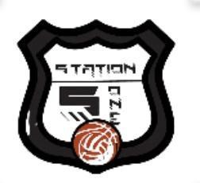
Station5ONE FALL & WINTER 2021 - 2022 PROGRAMMING GUIDE

Station5ONE 5 on 5 Winter Youth Basketball League

Jr NBA 2nd/3rd Grade- Wednesday - | | | 12 Game Guarantee | | | $20 Jersey Required
NBA 4th/5th Grade - Tuesday | | | 12 Game Guarantee | | | $20 Jersey Required

DIVISIONS | Jr NBA  2nd-3rd Grade Boys | NBA League 4th-5th Grade Boys
Winter League Sign Up Deadline | Nov. 4 | Nov. 4
Winter League Start Date | Nov. 17 | Nov. 16
Winter League Finish Date | Feb. 23 | Feb. 22
Winter League Individual Cost | $90 | $90
Winter League Team Cost | $725 | $725

Players must purchase a $20 jersey, not included in cost.
8 player per team minimum.

Station5ONE | www.station5one.com | info@station5one.com | 404 Olympia Dr

